INFOLABZ IT SERVICES PVT LTD

REACT | ASSIGNMENT 3 | 16 FEBRUARY 2024

**TASK 1**

You have to first download HTML template from following link and then observe all pages. This is template for Digital marketing / Web Design template. Check home page which is index.html

In home page there’s a portion ( see what’s going on portion ) that we can use to load news ( refer Assignment 2 ).

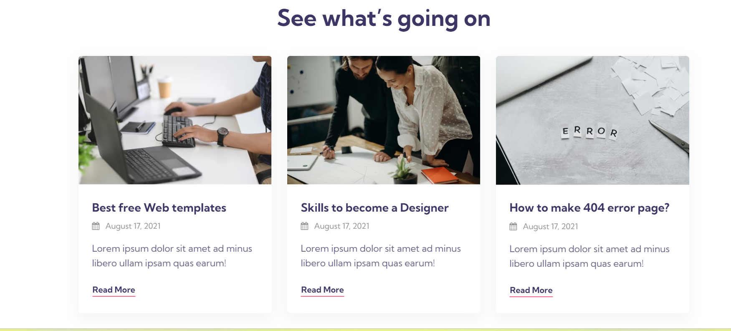

[CLICK HERE TO DOWNLOAD TEMPLATE](https://drive.google.com/file/d/1sD0E5xfboMCRQWdI65k493yLZ3sJ5kmX/view?usp=sharing)

Develop Entire news website using above template. ( More power to your simple bootstrap work )

Its always great to use best of the best layout / page available to develop your own code. EXPECTED OUTPUT is as follow

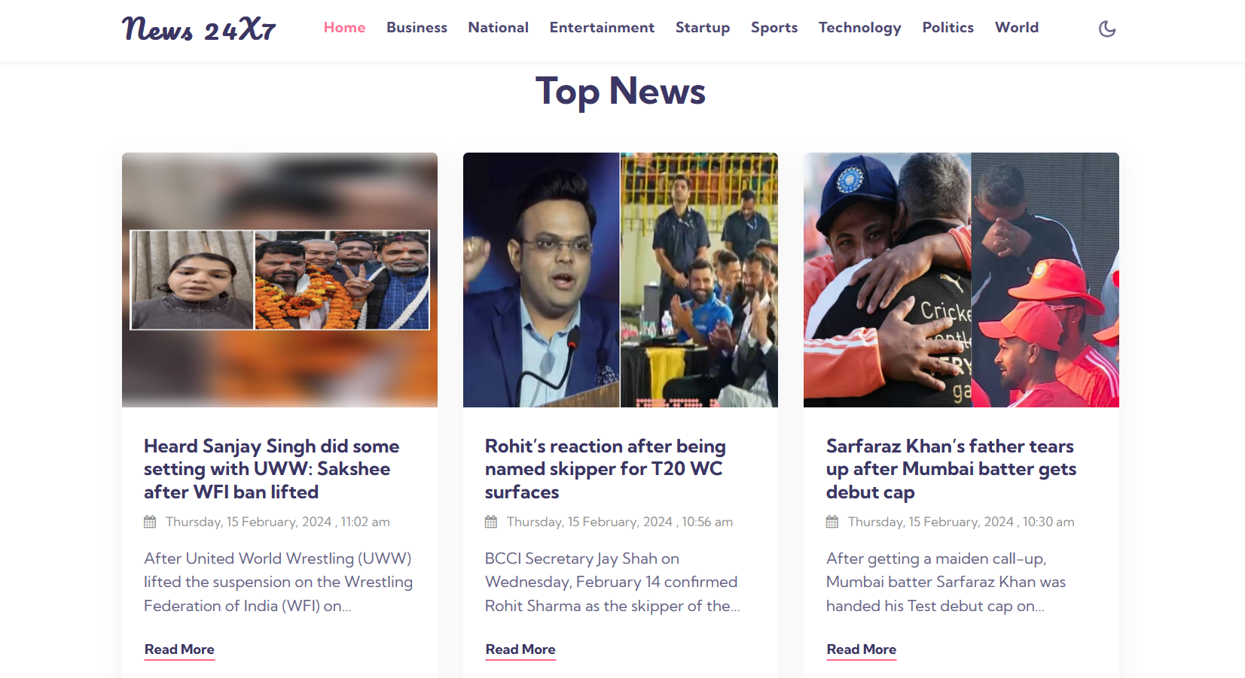

Things to take care in above output

1. On click of read more it should redirected to the link or corresponding news in new tab.
2. Maximum 3 lines of content should be displayed. After 3 lines display … ( three dots )

**TASK 2**

**React Material UI :** **Material UI** is an open-source **React** component library that implements Google's Material Design. It is use to create UI in react same like bootstrap.

Link : <https://mui.com/material-ui/>

STEP 1 : Install Material UI package in your react project.

STEP 2 : Create components as below. ( Same like we were creating in bootstrap, but in this project you have to read documentation of react material UI )

Create following Project using react material ui

| **Page Names** | **Project name :** muipractice |
| --- | --- |
| App.js | <h1>React Material UI </h1> |
| Btns.js  ( Button component ) | Containedbtn (DE), Outlinedbtn (E), Successbtn (E), Errorbtn (E) |
| msg.js  ( Table component ) | Alertmsg (DE), Warningalert(E), Erroralert(E) |
| extras.js  ( Alert component ) | Progessbar(DE), Infomsg (E), Successmsg (XE), Secondarymsg [Successmsg ] (E) |